**OBJECT ORIENTED PROGRAMMING**

***Department of Software Engineering***

#### Public Relations, MUET, SZAB Campus Khairpur Mir's - College & University | Facebook - 9,847 PhotosMentor:

##### Engr. Abdul Hafeez Babar [hafeez.babar@muetkhp.edu.pk](mailto:hafeez.babar@muetkhp.edu.pk)

***Mehran University of Engineering and Technology, SZAB Campus Khairpur Mir’s***

**Class, Object, Function/Method in Java**



* Object means a real-world entity such as a pen, chair, table, computer, watch, etc. Object-Oriented Programming is a methodology or paradigm to design a program using classes and objects.



###### It simplifies software development and maintenance by providing some concepts:

* + Object
  + Class
  + Inheritance
  + Polymorphism
  + Abstraction
  + Encapsulation

###### Apart from these concepts, there are some other terms which are used in Object-Oriented design:

* + Coupling
  + Cohesion
  + Association
  + Aggregation
  + Composition



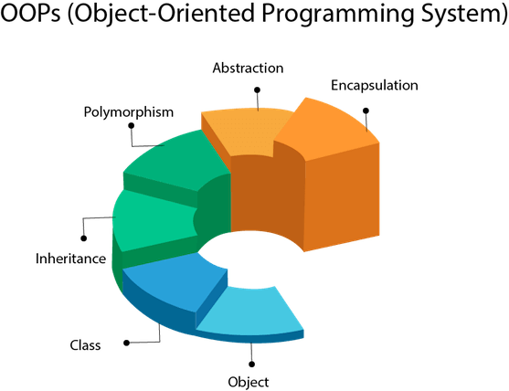

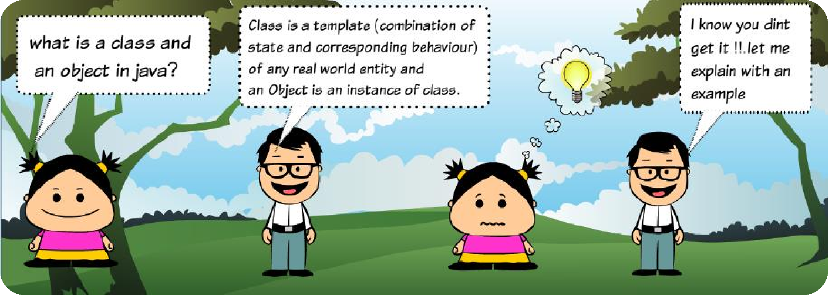

### Class and Object



**Engr. A. Hafeez Babar (MUET-SZAB)** [**hafeez.babar@muetkhp.edu.pk**](mailto:hafeez.babar@muetkhp.edu.pk)

### Class and Object

Now lets take our



What *are* the featurea *of '* k and «hita *in color and*

your pand»* weighs 500 pounds!

about his bahawiouri

### Class and Object

t He eats bamboP and sleep

t *through-out* the day!

; Now tHa features of panda cen be deacribed uaing

;/ea varJablas Pr flalds. And beha*dPur can be

t axprassed as methods./’Jw ffwa comBna both *ezata*

¿ and beha+/iour of a real lifs oI¿ject ws hava a class.



### Class and Object



**Engr. A. Hafeez Babar (MUET-SZAB)** [**hafeez.babar@muetkhp.edu.pk**](mailto:hafeez.babar@muetkhp.edu.pk)



### Class and Object



**Engr. A. Hafeez Babar (MUET-SZAB)** [**hafeez.babar@muetkhp.edu.pk**](mailto:hafeez.babar@muetkhp.edu.pk)

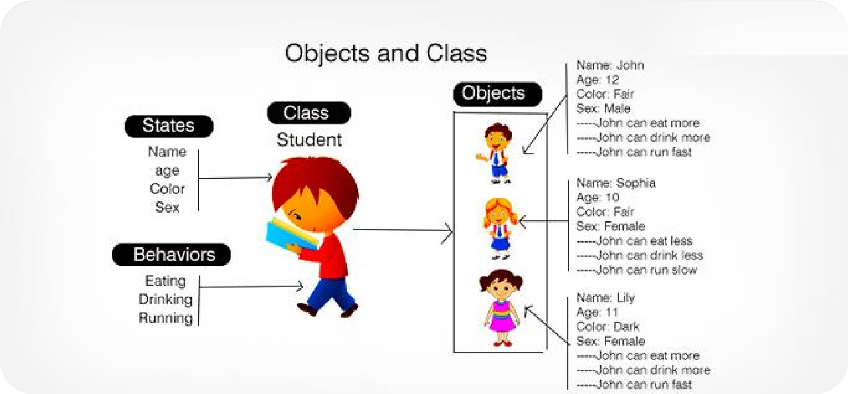

### Class and Object



**Engr. A. Hafeez Babar (MUET-SZAB)** [**hafeez.babar@muetkhp.edu.pk**](mailto:hafeez.babar@muetkhp.edu.pk)



**Object**



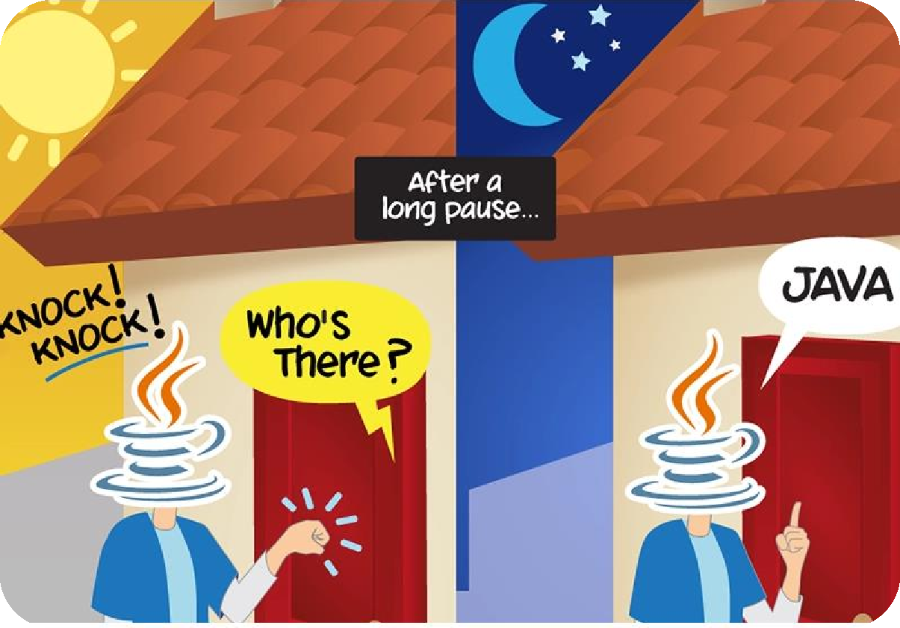

### Object



* + Any entity that has state and behavior is known as an object.
    - For example, a chair, pen, table, keyboard, bike, etc. It can be physical or logical.
  + An Object can be defined as an instance of a class.
  + An object contains an address and takes up some space in memory.
  + Objects can communicate without knowing the details of each other's data or code.
  + 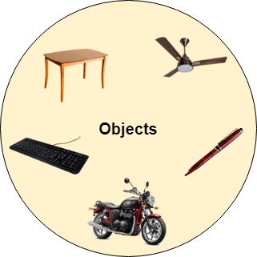The only necessary thing is the type of message accepted and the type of response returned by the objects.

##### Example:

* A dog is an object because it has states like color, name, breed, etc. as well as behaviors like wagging the tail, barking, eating, etc.

### Object



* An object in Java is the physical as well as a logical entity, whereas, a class in Java is a logical entity only.

##### An object has three characteristics:

* 1. ***State:*** represents the data (value) of an object.
  2. ***Behavior:*** represents the behavior (functionality) of an object such as deposit, withdraw, etc.
  3. ***Identity:*** An object identity is typically implemented via a unique ID. The value of the ID is not visible to the external user. However, it is used internally by the JVM to identify each object uniquely.

##### Example:

* Pen is an object. Its name is Reynolds; color is white, known as its state. It is used to write, so writing is its behavior.

### Object



* An object is an instance of a class. A class is a template or blueprint from which objects are created. So, an object is the instance(result) of a class.

#### Object Definitions:

* + An object is a real-world entity.
  + An object is a runtime entity.
  + The object is an entity which has state and behavior.
  + The object is an instance of a class.
* When you send a message to an object, you are asking the object to invoke or execute one of its methods as defined in the class.

### Java Objects



* For example, suppose Bicycle is a class then MountainBicycle, SportsBicycle, TouringBicycle, etc can be considered

as objects of the class.

**Creating an Object in Java**

className object = new className();

// for Bicycle class

Bicycle sportsBicycle = new Bicycle(); Bicycle touringBicycle = new Bicycle();

***Note:*** Fields and methods of a class are also called members of the class.

* We have used the new keyword along with the constructor of the class to create an object. Constructors are similar to methods and have the same name as the class. For example, Bicycle() is the constructor of the Bicycle class.
  + Here, sportsBicycle and touringBicycle are the names of objects. We can use them to access fields and methods of the class.
  + we have created two objects of the class. We can create multiple objects of a single class in Java.



**Class**

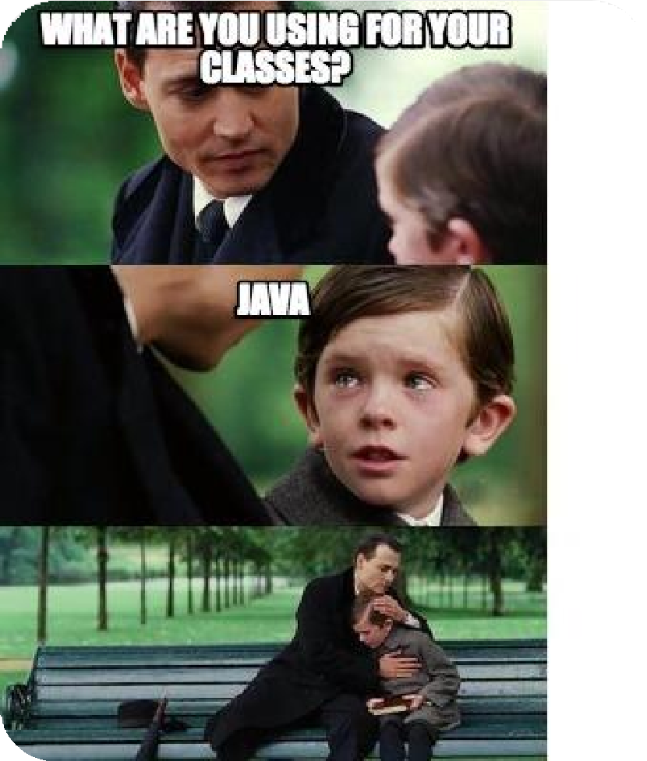

## Class



* + Collection of objects is called class. It is a logical entity.
  + A class can also be defined as a blueprint from which you can create an individual object. Class doesn't consume any space.
  + Before we create an object, we first need to define the class.
  + We can think of the class as a sketch (prototype) of a house. It contains all the details about the floors, doors, windows, etc. Based on these descriptions we build the house. House is the object.
  + Since many houses can be made from the same description, we can create many objects from a class

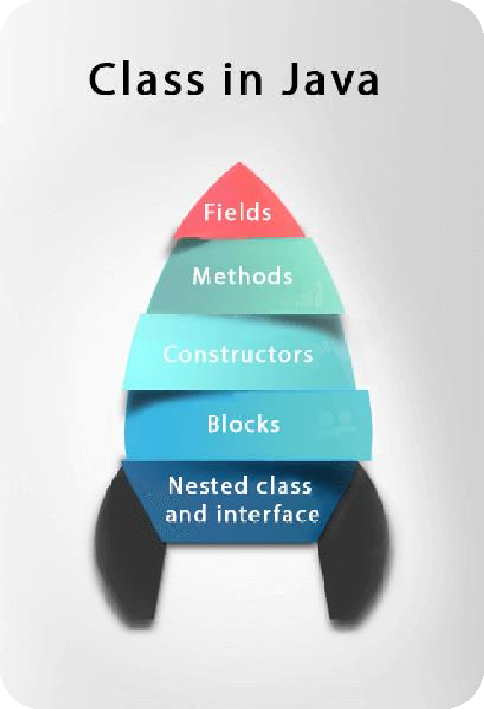

## Class



* + - A class is a group of objects which have common properties. It is a template or blueprint from which objects are created. It is a logical entity. It can't be physical.

###### A class in Java can contain:

* + - * Fields
      * Methods
      * Constructors
      * Blocks
      * Nested class and interface

**Syntax to declare a class:**

class <class_name>{

field; method;

}

**Engr. A. Hafeez Babar (MUET-SZAB)** [**hafeez.babar@muetkhp.edu.pk**](mailto:hafeez.babar@muetkhp.edu.pk)

**Create a class in Java**



* We can create a class in Java using the class keyword

##### For example

class ClassName {

// fields

// methods

}

* Here, fields (variables) and methods represent the state and behavior of the object respectively.
  + fields are used to store data
  + methods are used to perform some operations

### Create a class in Java



###### For our bicycle object, we can create the class as

class Bicycle {

// state or field private int gear = 5;

// behavior or method public void braking() {

System.out.println("Working of Braking");

}

}

* In the above example, we have created a class named Bicycle. It contains a field named gear and a method

named braking().

* Here, Bicycle is a prototype. Now, we can create any number of bicycles using the prototype. And, all the bicycles will share the fields and methods of the prototype.
* ***Note:*** We have used keywords private and public. These are known as access modifiers.

### Access Members of a Class



* + use the name of objects along with the . operator to access members of a class.

#### Example:

class Bicycle {

// field of class int gear = 5;

// method of class

void braking() {

...

}

}

* + In the above example, we have created a class named Bicycle. It includes a field named gear and a method named braking().

// create object

Bicycle sportsBicycle = new Bicycle();

// access field and method sportsBicycle.gear; sportsBicycle.braking();

### Instance variable in Java



* + - A variable which is created inside the class but outside the method is known as an instance variable.
    - Instance variable doesn't get memory at compile time. It gets memory at runtime when an object or instance is created. That is why it is known as an instance variable.

##### Example



**Object and Class Example: main within the class**

//Java Program to illustrate how to define a class and fields

//Defining a Student class. class Student{

//defining fields

int id;//field or data member or instance variable String name;

//creating main method inside the Student class

public static void main(String args[]){

//Creating an object or instance

Student s1=new Student();//creating an object of Student

//Printing values of the object System.out.println(s1.id);//accessing member through reference variable

System.out.println(s1.name);

}

}

##### Object and Class Example: main outside the class

//Java Program to demonstrate having the main

method in

//another class

//Creating Student class. class Student{

int id;

String name;

}

//Creating another class TestStudent1 which contains the main method

class TestStudent1{

public static void main(String args[]){ Student s1=new Student(); System.out.println(s1.id); System.out.println(s1.name);

}

}

### 3 Ways to initialize object



###### There are 3 ways to initialize object in Java:

1. **By reference variable**
2. **By method**
3. **By constructor**
4. **Object and Class Example: Initialization through reference**



* + Initializing an object means storing data into the object.

**Example:**

class Student{ int id;

String name;

}

class TestStudent2{

public static void main(String args[]){ Student s1=new Student(); s1.id=101;

s1.name="Sonoo";

System.out.println(s1.id+" "+s1.name);//printing members with a white space

}

}

##### Output: 101 Sonoo

* **We can also create multiple objects and store information in it through reference variable.**



**Example:**

class Student{ int id;

String name;

}

class TestStudent3{

public static void main(String args[]){

//Creating objects

Student s1=new Student(); Student s2=new Student();

//Initializing objects s1.id=101; s1.name="Sonoo"; s2.id=102; s2.name="Amit";

//Printing data System.out.println(s1.id+" "+s1.name); System.out.println(s2.id+" "+s2.name);

}

}

##### Output:

1. Sonoo
2. Amit

### Object and Class Example: Initialization through method



* + Creating the two objects of Student class and initializing the value to these objects by invoking the insertRecord method. Here, we are displaying the state (data) of the objects by invoking the displayInformation() method.

##### Example:

class Student{ int rollno; String name;

void insertRecord(int r, String n){ rollno=r;

name=n;

}

void displayInformation(){System.out.println(rollno+" "+name);}

}

class TestStudent4{

public static void main(String args[]){ Student s1=new Student();

Student s2=new Student(); s1.insertRecord(111,"Karan");

##### Output:

111 Karan

222 Aryan

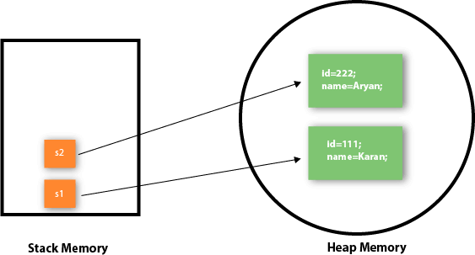

s2.insertRecord(222,"Aryan"); s1.displayInformation(); s2.displayInformation();

}

}

* + - Object gets the memory in heap memory area. The reference variable refers to the object allocated in the heap memory area. Here, s1 and s2 both are reference variables that refer to the objects allocated in memory.

### Object and Class Example: Initialization through a constructor



##### Object and Class Example: Employee

class Employee{ int id;

String name;

float salary;

void insert(int i, String n, float s) { id=i;

name=n; salary=s;

}

void display(){System.out.println(id+" "+name+" "+salary);}

}

public class TestEmployee {

public static void main(String[] args) { Employee e1=new Employee(); Employee e2=new Employee(); Employee e3=new Employee(); e1.insert(101,"ajeet",45000); e2.insert(102,"irfan",25000); e3.insert(103,"nakul",55000); e1.display();

e2.display();

e3.display();

}

}

##### Object and Class Example: Rectangle



**Example:**

class Rectangle{

int length;

int width;

void insert(int l, int w){ length=l;

width=w;

}

void calculateArea(){System.out.println(length*width);}

}

class TestRectangle1{

public static void main(String args[]){ Rectangle r1=new Rectangle(); Rectangle r2=new Rectangle(); r1.insert(11,5);

r2.insert(3,15); r1.calculateArea(); r2.calculateArea();

}

}



### What are the different ways to create an object in Java?



* + 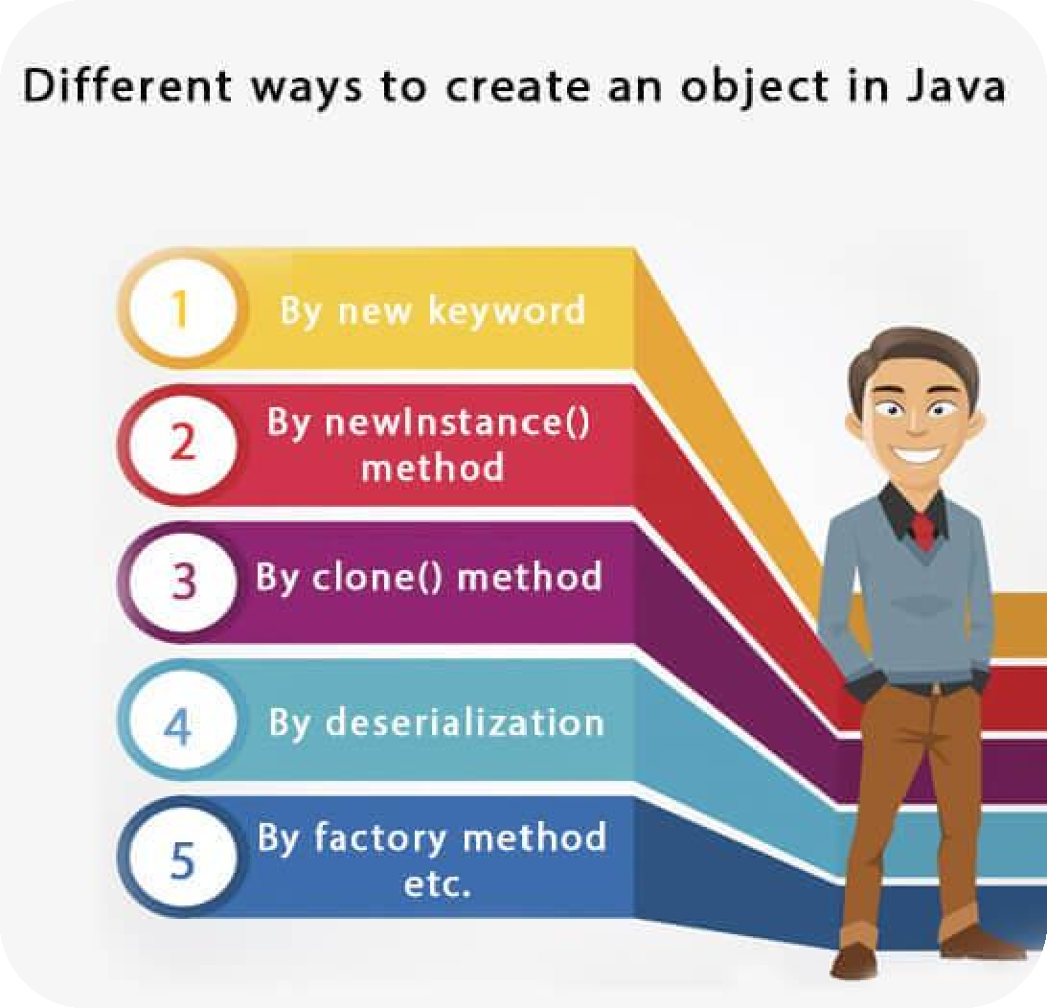By new keyword
  + By newInstance() method
  + By clone() method
  + By deserialization
  + By factory method etc.

### Reference / Anonymous object



* Anonymous simply means nameless. An object which has no reference is known as an anonymous object. It can be used at the time of object creation only.
* If you have to use an object only once, an anonymous object is a good approach.

#### Example:

##### new Calculation();//anonymous object

**Calling method through a reference:**

Calculation c=new Calculation(); c.fact(5);

##### Calling method through an anonymous object

new Calculation().fact(5);

### Anonymous object



#### Example:

class Calculation{ void fact(int n){ int fact=1;

for(int i=1;i<=n;i++){ fact=fact*i;

}

System.out.println("factorial is "+fact);

}

public static void main(String args[]){

new Calculation().fact(5);//calling method with anonymous object

}

}

### Creating multiple objects by one type only



• We can create multiple objects by one type only as we do in case of primitives.

##### Initialization of primitive variables

int a=10, b=20;

##### Initialization of reference variables:

Rectangle r1=new Rectangle(), r2=new Rectangle();//creating two objects

## new keyword in Java



* The new keyword is used to allocate memory at runtime. All objects get memory in Heap memory area.





**Method in Java**

### Method in Java



* + Method describes behavior of an object.
  + A method is a block of code which only runs when it is called.
  + Method in Java is a collection of instructions that performs a specific task.
  + You can pass data, known as parameters, into a method.
  + Methods are used to perform certain actions, and they are also known as functions.
  + It provides the reusability of code.
  + A method is a block of code or collection of statements or a set of code grouped together to perform a certain task or operation.

**Why use methods?** To reuse code: define the code once, and use it many times.

### Method Declaration



* + - The method declaration provides information about method attributes, such as visibility, return- type, name, and arguments.

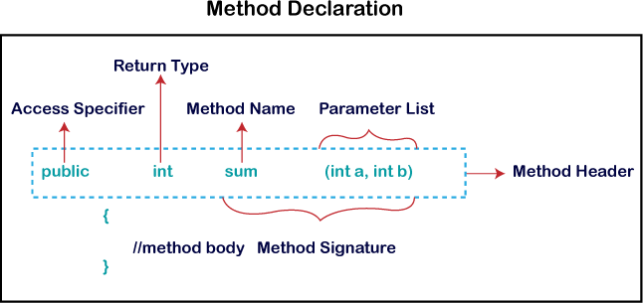

**Method Declaration(Continue…)**



***Method Signature:*** Every method has a method signature. It is a part of the method declaration. It includes the

method name and parameter list.

***Access Specifier:*** Access specifier or modifier is the access type of the method. It specifies the visibility of the method. Java provides four types of access specifier:

* ***Public:*** The method is accessible by all classes when we use public specifier in our application.
* ***Private:*** When we use a private access specifier, the method is accessible only in the classes in which it is defined.
* ***Protected:*** When we use protected access specifier, the method is accessible within the same package or subclasses in a different package.
* ***Default:*** When we do not use any access specifier in the method declaration, Java uses default access specifier by default. It is visible only from the same package only.

**Method Declaration(Continue…)**



***Return Type:*** Return type is a data type that the method returns. It may have a primitive data type, object, collection, void, etc. If the method does not return anything, we use void keyword.

***Method Name***: It is a unique name that is used to define the name of a method. It must be corresponding to the functionality of the method. Suppose, if we are creating a method for subtraction of two numbers, the method name must be subtraction(). A method is invoked by its name.

***Parameter List:*** It is the list of parameters separated by a comma and enclosed in the pair of parentheses. It contains the data type and variable name. If the method has no parameter, left the parentheses blank.

***Method Body:*** It is a part of the method declaration. It contains all the actions to be performed. It is enclosed within the

pair of curly braces.

### Naming a Method



* While defining a method, remember that the method name must be a verb and start with a lowercase letter.
* If the method name has more than two words, the first name must be a verb followed by adjective or noun.
* In the multi-word method name, the first letter of each word must be in uppercase except the first word.

##### Example:

Single-word method name: sum(), area()

Multi-word method name: areaOfCircle(), stringComparision()

* It is also possible that a method has the same name as another method name in the same class, it is known as

method overloading.

### Types of Method



There are two types of methods in Java:

* + Predefined Method
  + User-defined Method

#### Predefined Method

* Already defined in the Java class libraries
* Also known as the standard library method or built-in method.
* We can directly use these methods just by calling them in the program at any point.
* Some pre-defined methods are **length(), equals(), compareTo(), sqrt(),** etc.
* Such as print() method is defined in the java.io.PrintStream class. It prints the statement that we write inside the method. For example, print("Java"), it prints Java on the console.

#### User-defined Method



* The method written by the user or programmer is known as a user-defined method. These methods are modified according to the requirement.

### Create a Method



* + A method must be declared within a class.
  + It is defined with the name of the method, followed by parentheses ().
  + Java provides some pre-defined methods, such as System.out.println(), but you can also create your own methods to perform certain actions:

##### Example

**Create a method inside Main:**

public class Main {

static void myMethod() {

// code to be executed

}

}

public class Main {

static void myMethod() {

System.out.println("I just got executed!");

}

public static void main(String[] args) { myMethod();

}

}

// Outputs "I just got executed!"

##### A method can also be called multiple times:



**Example**

public class Main {

static void myMethod() { System.out.println("I just got executed!");

}

public static void main(String[] args) {

myMethod(); myMethod(); myMethod();

}

}

// I just got executed!

// I just got executed!

// I just got executed!

### Static Method



* A method that has static keyword is known as static method. In other words, a method that belongs to a class rather than an instance of a class is known as a static method. We can also create a static method by using the keyword static before the method name.
* The main advantage of a static method is that we can call it without creating an object. It can access static data members and also change the value of it. It is used to create an instance method. It is invoked by using the class name. The best example of a static method is the main() method.

### Example of static method



//**Display.java** public class Display

{

public static void main(String[] args)

{

show();

}

static void show()

{

System.out.println("It is an example of static method.");

}

}

### Instance Method



* The method of the class is known as an instance method. It is a non-static method defined in the class. Before calling or invoking the instance method, it is necessary to create an object of its class.

#### Example:

public class InstanceMethodExample

{

public static void main(String [] args)

{

//Creating an object of the class

InstanceMethodExample obj = new InstanceMethodExample();

//invoking instance method System.out.println("The sum is: "+obj.add(12, 13));

}

int s;

//user-defined method because we have not used static keyword public int add(int a, int b)

{

s = a+b;

//returning the sum

return s;

}

}

#### There are two types of instance method:



1. Accessor Method
2. Mutator Method

**Accessor Method:** The method(s) that reads the instance variable(s) is known as the accessor method. We can easily identify it because the method is prefixed with the word get. It is also known as getters. It returns the value of the private field. It is used to get the value of the private field.

##### Example

public int getId()

{

return Id;

}

**Mutator Method:** The method(s) read the instance variable(s) and also modify the values. We can easily identify it because the method is prefixed with the word set. It is also known as setters or modifiers. It does not return anything. It accepts a parameter of the same data type that depends on the field. It is used to set the value of the private field.



##### Example

public void setRoll(int roll)

{

this.roll = roll;

}

#### Example of accessor and mutator method



##### Example: Student.java

public class Student

{

private int roll; private String name;

public int getRoll() //accessor method

{

return roll;

}

public void setRoll(int roll) //mutator method

{

this.roll = roll;

}

.

.

.

public String getName()

{

return name;

}

public void setName(String name)

{

this.name = name;

}

public void display()

{

System.out.println("Roll no.: "+roll); System.out.println("Student name: "+name);

}

}





# Java Method

**Parameters**

### Parameters and Arguments



* + Information can be passed to methods as parameter. Parameters act as variables inside the method.
  + 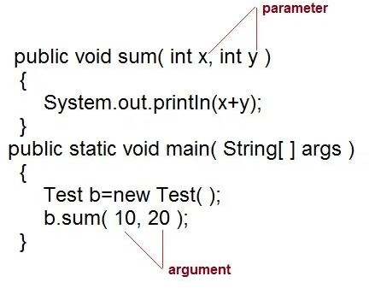Parameters are specified after the method name, inside the parentheses. You can add as many parameters as you want, just separate them with a comma.
  + Parameter are always local to the method they don't have scope outside the method. While argument is a value that is passed to a method when it is called.





### call-by-value

**and call-by-reference**

**call-by-value and call-by-reference**



***There are two ways to pass an argument to a method***

1. **call-by-value:** In this approach copy of an argument value is pass to a method. Changes made to the argument value inside the method will have no effect on the arguments.
2. **call-by-reference:** In this reference of an argument is pass to a method. Any changes made inside the method will affect the argument value.

***NOTE:*** However there is no concept of call-by-reference in Java. Java supports only call by value.

**Example**



public class Main {

static void myMethod(String fname) { System.out.println(fname + " Refsnes");

}

public static void main(String[] args) { myMethod(“Ali"); myMethod(“Waqar"); myMethod("Ahmed");

}

}

// Ali Refsnes

// Waqar Refsnes

// Ahmed Refsnes

When a parameter is passed to the method, it is called an argument. So, from the example above: fname is a parameter, while Ali, Waqar and Ahmed are arguments.

### Example of call-by-value



public class Test

{

public void callByValue(int x)

{

x=100;

}

public static void main(String[] args)

{

int x=50;

Test t = new Test();

t.callByValue(x); //function call System.out.println(x);

}

}

* + - In the above example, value passed to the method does not change even after modified in the method. It shows that changes made to the value was local and argument was passed as call-by-value.

### Java is Strictly Pass by Value



* + - In Java, it is very confusing whether java is pass by value or pass by reference.
    - When the values of parameters are copied into another variable, it is known as pass by value and when a reference of a variable is passed to a method then it is known as pass by reference.
    - It is one of the feature of C language where address of a variable is passed during function call and that reflect changes to original variable.
    - In case of Java, we there is no concept of variable address, everything is based on object. So either we can pass primitive value or object value during the method call.

***Note:*** Java is strictly pass by value. It means during method call, values are passed not addresses.

#### Example:



class Demo

{

public static void main(String[] args)

{

Add obj = new Add(5, 10);

// call by value change(obj.x, obj.y);

System.out.println("x = "+obj.x); System.out.println("y = "+obj.y);

}

public static void change(int x, int y)

{

x++; y++;

}

}

* Below is an example in which value is passed by value and changed them inside the function but outside the function changes are not reflected to the original variable values.

class Add

{

int x, y;

Add(int i, int j)

{

x = i; y = j;

}

}

* Lets take another example in which an object is passed as value to the function, in which we change its variable value and the changes reflected to the original object. It seems like pass by reference but we differentiate it. Here member of an object is changed not the object.



#### Example

class Demo

{

public static void main(String[] args)

{

Add obj = new Add(5, 10);

// call by value (object is passed) change(obj); System.out.println("x = "+obj.x); System.out.println("y = "+obj.y);

class Add

{

int x, y; Add(int i, int j)

{

x = i;

y = j;

} }

public static void change(Add add) }

{

add.x++; add.y++;

}

}

#### Multiple Parameters



* + You can have as many parameters as you like:

#### Example:

public class Main {

static void myMethod(String fname, int age) { System.out.println(fname + " is " + age);

}

public static void main(String[] args) { myMethod("Liam", 5);

myMethod("Jenny", 8);

myMethod("Anja", 31);

***Note:*** when you are working with multiple

parameters, the method call must have the same number of arguments as there are

}

} parameters, and the arguments must be passed

// Liam is 5

// Jenny is 8

// Anja is 31

in the same order.

### Return Values



* The void keyword, used in the previous examples , indicates that the method should not return a value. If you want the method to return a value, you can use a primitive data type (such as int, char, etc.) instead of void, and use the return keyword inside the method:

#### Example

public class Main {

static int myMethod(int x) { return 5 + x;

}

public static void main(String[] args) { System.out.println(myMethod(3));

}

}

// Outputs 8 (5 + 3)

Returns the sum of a method's two parameters:

##### Example:

public class Main {

static int myMethod(int x, int y) {

return x + y;

}

public static void main(String[] args) { System.out.println(myMethod(5, 3));

}

}

// Outputs 8 (5 + 3)

You can also store the result in a variable (recommended, as it is easier to read and maintain):

##### Example:



public class Main {

static int myMethod(int x, int y) { return x + y;

}

public static void main(String[] args) { int z = myMethod(5, 3); System.out.println(z);

}

}

// Outputs 8 (5 + 3)

* Returns the sum of a method's two parameters:

##### Example:

public class Main {

static int myMethod(int x, int y) {

return x + y;

}

public static void main(String[] args) { System.out.println(myMethod(5, 3));

}

}

// Outputs 8 (5 + 3)

* You can also store the result in a variable (recommended, as it is easier to read and maintain):

##### Example:



public class Main {

static int myMethod(int x, int y) { return x + y;

}

public static void main(String[] args) { int z = myMethod(5, 3); System.out.println(z);

}

}

// Outputs 8 (5 + 3)

### A Method with If...Else



* + It is common to use if...else statements inside methods:

##### Example:

public class Main {

// Create a checkAge() method with an integer variable called age

static void checkAge(int age) {

// If age is less than 18, print "access denied" if (age < 18) {

System.out.println("Access denied - You are not old enough!");

// If age is greater than, or equal to, 18, print "access granted"

} else {

System.out.println("Access granted - You are old enough!");

}

}

public static void main(String[] args) {

checkAge(20); // Call the checkAge method and pass along an age of 20

}

}

// Outputs "Access granted - You are old enough!"

### Abstract Method



* + The method that does not has method body is known as abstract method.
  + In other words, without an implementation is known as abstract method.
  + It always declares in the abstract class. It means the class itself must be abstract if it has abstract method.
  + To create an abstract method, we use the keyword abstract.

##### Syntax

abstract void method_name();

### Example of abstract method



**Demo.java** abstract class Demo //abstract class

{

//abstract method declaration abstract void display();

}

public class MyClass extends Demo

{

//method impelmentation void display()

{

System.out.println("Abstract method?");

}

public static void main(String args[])

{

//creating object of abstract class Demo obj = new MyClass();

//invoking abstract method

obj.display();

}

}

